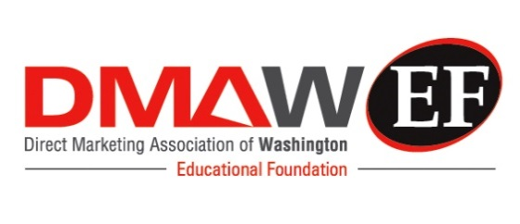
The INTENTION TO COMPETE/ATTEND-Spring 2021
DMAW/EF, Amy Steinbicker, Executive Administrator
200 Little Falls Street, #205
Falls Church, VA 22046
administrator@dmawef.org 703-407-1663

PROFESSORS/ADVISORS and/or TEAM LEADER(S):
Intention to compete/attend form for the DMAW/EF Collegiate MAXI Competition
This Intent Form is due COB Friday, March 19; Case Competition to be held Friday, April 16, 2021.
The first 6 teams to register will be able to compete at the Case Competition.

Name/Title of Prof/Leader: ________________________________________________________
Number of attending teams? Circle: One Two
College/University: _______________________________________________________________
Department/School: ________________________________________________________________
Address: __________________________________________________________________________
City/State/Zip:____________________________________________________________________
Cell Phone:_________________________________ Email:______________________________________________
Please send this “Intent to Compete/Attend” form no later than March 19, 2021, and provide the following information:
I plan to have _______ teams (2-4 students each team) compete in the Spring 2021 Collegiate Maxi Case Competition.
Team 1 is composed of entirely_____ undergraduate _____ graduate students.
Team 2 is composed of entirely_____ undergraduate _____ graduate students.

- For the spring competition, there will be one case option: World Wildlife Fund
My students will do this:
___ as a mandatory class project
___ as a marketing club function
___ as a class project with voluntary participation
___ as an Independent Study Project
___ other (please describe)______________________________________________________________________________

I hope to have _______ student observers in addition to team members who will be participating virtually; two guests (max) in addition to team members, prof or leader. Total attendees attending competition from school: _______

I agree by entering the competition, faculty advisors and participants (entrants) agree to grant DMAW/EF the unlimited right to use their names, recordings, pictures and/or likenesses for advertising and publicity purposes, whether utilized in print media, television, video, film, radio, internet, or otherwise, without their prior review or approval, and without any compensation to them. Participants agree that all entries become the shared property of DMAW/EF and the case competition organization and will not be returned to the contestants or faculty advisors, nor will compensation be paid to participants.

Faculty Advisor/Team Leader: Name (please print):_________________________________________________

Faculty Advisor/Leader Signature: ________________________________________________________

(Please move to Page 2 and complete as necessary.)

Team 1:
_____ Undergraduate _____ Graduate

Student Name | Email | Current (Fresh, Soph, JR, SR, Grad)

Team 2, if applicable:
_____ Undergraduate _____ Graduate

Student Name | Email | Current (Fresh, Soph, JR, SR, Grad)

Other student observers or professors attending, if applicable (in addition to those already listed):

Name | Email | Type (student observer, advisor, TA, etc.)

Below, please list the person who will be primary point of contact regarding all communications for this competition.

Name | Email | Mobile Phone

Due March 19, 2021 Please complete as much as possible, and email scanned signed form back to: administrator@dmawef.org
Questions? Contact: DMAW/EF, Amy Steinbicker, Executive Administrator
200 Little Falls Street, #205
Falls Church, VA 22046
administrator@dmawef.org 703-407-1663

