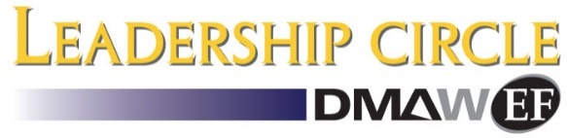
Direct Marketing Association of Washington Educational Foundation
200 Little Falls St., #205, Falls Church, VA 22046 | 703-407-1663| dmawef.org

The DMAW/EF Leadership Circle was established in 2008 to support programs that link professors, students and direct marketing organizations. Leadership Circle membership helps to fund many essential programs, such as student mentoring/internships/placement days through the Mentor for a Day program, the Professors’ Institute, Collegiate Maxi Competition, Academic Advisory Council and much more.

The proceeds from your donation help us educate college students about the possibilities of, and potential in, a direct marketing career. Help us support the next generation of direct marketing leaders.

The EF is making a difference in the direct marketing community by connecting students, academia and business executives through our highly effective programs.

With your help we can continue to mold the future of the direct marketing industry by supporting the education of students in the field. Your commitment and your contribution will make a meaningful difference in the lives of the next generation of direct marketers.

Sincerely,

Courtney Lewis
DMAW/EF President-elect

Yes! I would like to support the DMAW/EF and its goal with my contribution.

Name:______________________________________ Title: __________________________
Company or Organization:_____________________________________________________
Address: __________________________________________________________________
City: ____________________________________ State: _________ Zip: _______________
Email: ________________________________ Phone: ______________________________
Contribution: $50 $100 $250 $500 $1000
Your Best Gift $ __________________________________

I would like to personally help with one of the following EF Programs:
Collegiate MAXI Competition Professors’ Institute Mentor for a day Program

Payment Method: AMEX Visa MasterCard Check enclosed Cash enclosed
Credit Card #: ___________________________ Exp ____/______ Security Code: ________
(3 digits on Visa or MC or 4 digits on AMEX)
Signature: ________________________________________
Please make checks payable to the DMAW/EF, 200 Little Falls Street #205, Falls Church, VA 22046

The IRS has determined that DMAW Educational Foundation, Inc., is a tax-exempt public charity as described in Section 501 (c) (3) of the Internal Revenue Code, and your contribution is fully tax-deductible to the extent permitted by law

